**Hospital Appointment Management System**

**An Internship Report**

***Submitted By***

**Mulchandani Tarunkumar Balchandbhai**

**190170107072**

***In partial fulfillment for the award degree of***

**BACHELOR OF ENGINEERING**

***in***

**Computer Engineering**

**Vishwakarma Government Engineering College,**

**Chandkheda, Ahmedabad-382424**



**Gujarat Technological University, Ahmedabad**

**January-April, 2023**



VISHWAKARMA GOVERNMENT ENGINEERING COLLEGE

CHANDKHEDA, AHMEDABAD

### **CERTIFICATE**

This is to certify that the Project report submitted along with the project entitled **Hospital Appointmnet Management System** has been carried out by **Mulchandani Tarunkumar Balchandbhai** Enrollment no. **190170107072** under my guidance in partial fulfilment for the degree of Bachelor of Engineering in Computer Science, 8th Semester of Gujarat Technological University, Ahmedabad during the academic year 2022-23.

Prof. Kajal Patel Prof. Mansukh Savaliya

Internal Guide Head of the Department

Assistant Professor Associate Professor

|  |  |  |
| --- | --- | --- |
| A r g u s o f t | I n d i a | L t d. |

Argus

May 3, 2023

**Project Completion Certificate**

This is to certify that **Mr Tarunkumar Mulchandani** has successfully completed his final year project entitled **“Hospital Appointment Management System”** from date 23/01/2023 to 23/04/2023.

**Technology Used: Angular, Spring Boot, MySQL**

**Project Coordinator: Braj Dangi**

**Mentor: Mr. Dhruvkumar Patel**

He has a bright and analytical mind. He is good at his concepts and implemented them

effectively in the modules assigned to him during his project. During the project, we found him sincere, honest, and hardworking.



**Signature**

We wish him all the best for his future.

**Project Guide Mentor**

**(Mr. Braj Dangi) (Mr. Dhruvkumar Patel)**

A66, Sector 25, GIDC Electronic Estate, Gandhinagar 382 016. Gujarat, INDIA

[www.argusoft.com](http://www.argusoft.com) | hr@argusoft.com



VISHWAKARMA GOVERNMENT ENGINEERING COLLEGE

CHANDKHEDA, AHMEDABAD

COMPUTER DEPARTMENT

### **DECLARATION**

I hereby declare that the Internship report submitted along with the internship project entitled **Hospital Appointment Management System** submitted in partial fulfilment for the degree of Bachelor of Engineering in Computer Engineering to Gujarat Technological University, Ahmedabad, is a bonafide record of original project work carried only by me at Argusoft India Pvt Ltd under the supervision of prof. Kajal Patel and that no part of this report has been directly copied from any students reports or taken from any other source, without providing due reference.

Name of the Student Sign of Student

Tarun Mulchandani

### **ACKNOWLEDGEMENT**

The satisfactory completion of the internship duration would not have been with out the people who guided and supported me with my journey as an intern at Argusoft India Pvt. Ltd.

Firstly I would like to thank Mr. Braj Dangi who is Head of HR at Argusoft India Pvt. Ltd. who provided me this great opportunity to do an internship with the organization. I would also like to thank Mr. Dhruvkumar Patel who was my mentor at company during my internship tenure. I would also like to thank all my colleagus and the co-members of the Argusoft India Pvt. Ltd. who played a supportive role during this tenure.

I would specially like to express my gratitude towards Prof.Kajal Patel at Vishwakarma Government Engineering college. I am thankful to her for his continuous support and -encouragement. She guided me with many difficulties.

I would also like to express my gratitude toward Prof. Mansukh Savliya for guiding me with his experience.

### **ABSTRACT**

This report is about my experience of internship at Argusoft India Pvt Ltd. This internship learnt me many things regarding the software industry and web development. I learnt about managing various versions of the software, necessary database related core concepts, server side technologies and frameworks, front end frameworks ,how to work on production applications, doing pair programming, working collaboratively in team environment.

During this tenure I learnt and worked with various technologies which includes version control systems such as git, databases such and MySql and MongoDB, backend technologies such as spring mvc and spring boot and frontend frameworks such as Angular.

I made use of those learnings in implementations of “Hospital Management System” project.

During this tenure I got exposure to the industrial environment and practices which I feel is the primary objective of Internships. I feel this learnings will help me to grow in my professional life.

**List of Figures**

|  |  |
| --- | --- |
| **Figure Name** | **Page No.** |
|  |  |
|  |  |
|  |  |
|  |  |
|  |  |
|  |  |
|  |  |
|  |  |

**List of Tables**

|  |  |
| --- | --- |
| **Table Name** | **Page No.** |
|  |  |
|  |  |
|  |  |
|  |  |
|  |  |
|  |  |
|  |  |
|  |  |

**List of Abbrivarion**

|  |  |
| --- | --- |
| **Abbrication** | **Full Form** |
| Api | Application Program Interface |
| Cli | Command Line Interface |
| Sql | Structured Query Language |
| REST | Representational State Transfer |
| JSON | JavaScript Object Notation |
| JWT | Json Web Token |
| UI/UX | User Interface/User Experience |
| Dev | developer |

**Table Of Contents**

Acknowledgement………………………………………………………….1

Abstract…………………………………………………………………….

List Of Figures……………………………………………………………..

List Of Tables……………………………………………………………….

List Of Abbrivations…………………………………………………………

Table Of Contents…………………………………………………………….

**Chapter-1: Overview of the company………………………………**

* 1. History………………………………………………………………
  2. DIFFERENT PRODUCT / SCOPE OF WORK……………………

**Chapter-2: OVERVIEW OF DIFFERENT DEPARTMENT AND PRODUCTION/PROCESS BEING CARRIED OUT IN COMPANY**

* 1. Departments………………………………………………………
  2. Production process followed by company ……………………

**Chapter-3: Introduction to Internship**

1. Departments………………………………………………………
2. Purpose …………………………………………………………
3. Objective………………………………………………………
4. Scope……………………………………………………………
5. Technological and literature review…………………………….
6. Internship Scheduling…………………………………………..

**Chapter-4: System Analysis**

1. Study of Current System
2. Problems and Weakness of current system
3. Requirement of the new system
4. System Feasibility
5. Activity in the new system
6. List of main components in the system

**Chapter-5: System Design**

1. Data Flow Diagram
2. Data Dictionary
3. ERD
4. RestApi Resources

**Chapter-6: Implementation**

1. Tools
2. Module Specification and Implementation Overview

**Chapter-7: Testing**

**T**

**Chapter-1:Overview of the company**

* 1. **History**

Argusoft started back in 2000 as a services company, engaged in providing intensive hands-on training to produce enhanced Peoplesoft professionals from India. In the early days, the company followed an onsite-offshore model, where it worked with an American company Intelliant to provide these resources for placement in projects in the US. Soon thereafter Argusoft migrated to provide more value-add through offshore IT engineering services as that was the emerging paradigm shift at that time.

* 1. **DIFFERENT PRODUCT / SCOPE OF WORK**

They augment client teams with their software development, testing, maintenance and support. Their primary focus is Business Automation and SOA system integration, leveraging Java, PHP, dot Net and Web 2.0 related technologies. We deliver these services as turnkey projects or through our extended team model (mODC - managed Offshore Development Center), providing a completely managed team, to ensure continuity and efficiency. Following are the services provided by the company:-

* **mODC**

Managed Offshore Development Center model, provides a managed team of developers, as an extension of client teams, with access to peripheral resources like BA, UI/UX, QA as needed

* **Turnkey Solution**

Providing end to end IT software system integration solutions to their customers based on their custom requirements, using the latest tools and technologies - Define-DevelopDeploy-Support

* **Third Party QA**

Dedicated team to ensure an objective testing of clientsoftware system to enable a faster, more confident launch.

* **Mobile Development**

Keeping pace with the latest in mobile technologies, they develop enterprisegrade cross-platform mobile applications.

* **DevOps Consultancy Service**

Helping client to build a DevOps environment from scratch and redefine your delivery & deployment strategy through our services.

**Chapter-2:**  **OVERVIEW OF DIFFERENT DEPARTMENT AND PRODUCTION/PROCESS BEING CARRIED OUT IN COMPANY.**

**2.1 Departments**

* **Business Department:**

Business department deals with the market analysis and requirement analysis for the services provided by the Argusoft.

* **HR departments:**

Human resources department manages with the emoployees and interns availability and productivity related activities.

* **Accounts Department:**

Account department deals with billings and salary related activities within the company

* **Software Development Department:**

Software development department consists of the team of people who develop the software as per the client requirement.

* **QA department:**

QA department ensures the quality of the software being delivered by testing and related activities.

* **DevOps department:**

DevOps department deals with the operational activities those are associated with the software development activities such as integration and deployment.

**2.2 Production process followed by company**

Here is the process diagram shown about the process that is being followed for the development

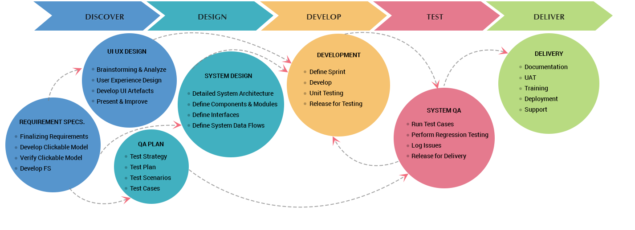

[Figure 2.2.1 – Production Process]

**Chapter-3: Introduction to Internship**

**3.1 Internship Summary**

The main objective of the inclusion of internship into curriculum is to make a student industry ready and make him learn how to apply his knowledge to encounter industrial challenges. My experience of the internship at the Argusoft was a great learning experience. Initially I was provided the training of various technologies related web development. I learnt basics of the programming languages and their related frameworks. I then created some demo features that involved my learnings. Than I started implementation of the “Hospital Management System” project. I learnt many dynamic aspects of web development through it.

I also had a great interpersonal experience at the work environment which is really friendly.

**3.2 Purpose**

The purpose of the internship is to make a student industry ready and be able to make a career in the ever growing industry. Acadamics knowledge make students aware about the technologies and terminologies, yet market demands advanced skill set and technologies. The purpose is to expose students to this industrial knowledge.

**3.3 Objective**

Here are the objecives of the internship

* Make student learn to make necessary diagrams and charts that can help to the engineering practices.
* Learning to implement various system designs and understand the requirement of the project.
* Make student to learn how to work in collaborative team environments and understand challenges.

**3.4 SCOPE**

The work log feature in the Employee Management System enables an employee to log his/her extra work and its details i.e., hours, date, and description of extra work. The worklog data is validated by a manager under which the employees are working. This validated data stored is used to generate some meaningful statistics about the total extra hours worked by every employee under the client’s project and the statistic is then used by a Customer Relationship Manager (CRM) to charge the client accordingly.

**3.5 Technology and literature review**

During this Internship I came across various technologies which were necessary building blocks for web based application and softwares.

* **Git**

Git is a famous free and open source distributed version control system. Git is used to manage various version of the software. I learnt about the branching using git.



[Figure 3.5.1-git logo]

* **MySQL**

MySQL is the famous sql based relational database. It is widely used worldwide and ideal for large enterprise application and small projects too.



[Figure 3.5.2-MySql logo]

* **Java**

Java is one of the most famous programming languages which follows the object oriented programming paradigim.



[Figure 3.5.3-Java logo]

* **Spring**

Spring is one of the most famous java technologies which follows the dependency injection and help to manage loosly coupled code. Technologies such as Spring Boot elementaes the boiler plate code and make development easy and focus on business logic rather than configuration



[Figure 3.5.4-Spring logo]

* **Angular**

Angular is the famous typescript based front-end framework managed by Google. It is widely used for enterprise applications.



[Figure 3.5.5-Angular logo]

**3.6 Internship Scheduling:**

Internship tenure of the 12 weeks can be divided into basically 2 time zones

* **Week 1-8 Training:**

Initial 8 weeks were the training for the technologies via various courses and learning how to implement them

* **Week 9-12 Implementation :**

Once training was finished I started the implementation of the Project that was assigned to me.

**Chapter-4: System Analysis**

**4.1 Study of current system:**

There is a system “PsycOnline” which serves the system for the appointment system. Using PsychOnline appointments can be scheduled to the various hospitals.

**4.2 Problem and weakness of the current system.**

One issue with the current system is that the user interface they provide is a bit complex and not easily accisable by everyone.

**4.3 Requirement of the new system**

The new system aims to provide an easy to use interface that make user interaction to the system easy for everyone and make it widely useful and make the service accisable to the larger public.

**4.4 System Feasibility**

The proposed system can be implemented using the current technologies within the given time constraints. It will make health facility accisable to the wide set of the audience. This system requires no fancy hardware as can be accessed via a device that can access the web.

**4.5 Activity in the new system**

Hospitals can register themshelves to the system. There will be an admin panel available to them. From here they can add new doctors details to the system and modify their details. They can keep tracks of the appointments associated to the hospital, They can analyze the data via dashboard components.

Doctors can register to the system via credentials provided by the HospitalAdministation. They can keep the track of their patients and appointments and also generate diagnosis report for the patient

User can sign in to the system and can add multiple patients and can book the appointments for them and keep track of all past and upcoming appointments and modify patient details.

**4.6 List of main components in the system**

* Signup page
* Login Page
* Doctors List page
* Hospital Admin Dashboard
* Patients List Page
* User side dashboard
* Appointment List Page
* Diagnosis report generation

**Chapter-5: System Design**

**5.1 Data Flow Diagram**

* **0 Level DFD:**

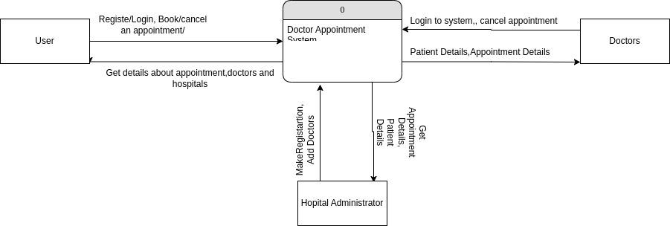

[Figure 5.1.1-0-Level-DFD]

* **1 level DFD:**

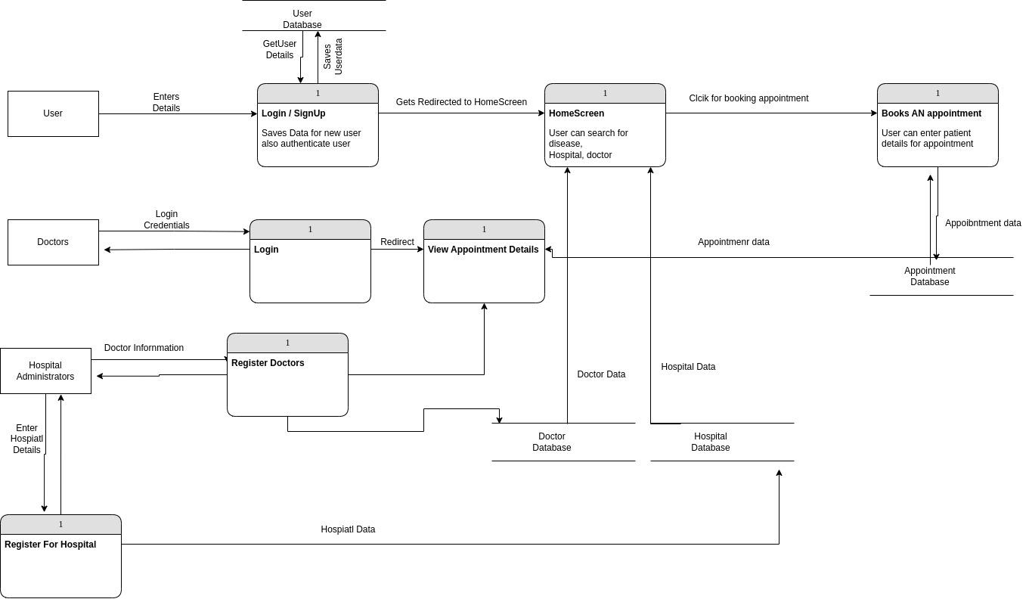

[Figure 5.1.2-1-Level-DFD]

**5.2 Data Dictionary**

* **Users**

|  |  |  |
| --- | --- | --- |
| **Column Name** | **Data Type** | **Constraints** |
| userId | INT | NOT NULL, AUTO_INCREMENT, PRIMARY KEY |
| firstName | VARCHAR(255) | NOT NULL |
| lastName | VARCHAR(255) | NOT NULL |
| email | VARCHAR(255) | UNIQUE, NOT NULL |
| contactNo | VARCHAR(255) | UNIQUE, NOT NULL |
| password | VARCHAR(255) | NOT NULL |
| dob | DATE |  |
| address | VARCHAR(255) |  |
| createdAt | TIMESTAMP | DEFAULT CURRENT_TIMESTAMP |
| updatedAt | TIMESTAMP | DEFAULT CURRENT_TIMESTAMP ON UPDATE CURRENT_TIMESTAMP |

[Table 5.2.1-Data-Dictionary-Users]

* **Patient**

|  |  |  |
| --- | --- | --- |
| **Column Name** | **Data Type** | **Constraints** |
| patientId | INT | NOT NULL, AUTO_INCREMENT, PRIMARY KEY |
| patientFirstName | VARCHAR(255) | NOT NULL |
| patientLastName | VARCHAR(255) | NOT NULL |
| userId | INT | NOT NULL, FOREIGN KEY (userId) REFERENCES Users(userId) |
| patientContactNo | VARCHAR(255) | NOT NULL |
| dob | DATE |  |
| createdAt | TIMESTAMP | DEFAULT CURRENT_TIMESTAMP |
| updatedAt | TIMESTAMP | DEFAULT CURRENT_TIMESTAMP ON UPDATE CURRENT_TIMESTAMP |

[Table 5.2.2-Data-Dictionary-Patient]

* **Disease**

|  |  |  |
| --- | --- | --- |
| **Column Name** | **Data Type** | **Constraints** |
| diseaseId | INT | NOT NULL, AUTO_INCREMENT, PRIMARY KEY |
| diseaseName | VARCHAR(255) | NOT NULL |
| createdAt | TIMESTAMP | DEFAULT CURRENT_TIMESTAMP |
| updatedAt | TIMESTAMP | DEFAULT CURRENT_TIMESTAMP ON UPDATE CURRENT_TIMESTAMP |

[Table 5.2.3-Data-Dictionary-Disease]

* **Hospital**

|  |  |  |
| --- | --- | --- |
| **Column Name** | **Data Type** | **Constraints** |
| hospitalId | INT | NOT NULL, AUTO_INCREMENT, PRIMARY KEY |
| hospitalName | VARCHAR(255) | NOT NULL |
| hospitalAddress | VARCHAR(255) | NOT NULL |
| hospitalContactNo | VARCHAR(255) | UNIQUE |
| hospitalEmail | VARCHAR(255) | UNIQUE, NOT NULL |
| password | VARCHAR(255) | NOT NULL |
| createdAt | TIMESTAMP | DEFAULT CURRENT_TIMESTAMP |
| updatedAt | TIMESTAMP | DEFAULT CURRENT_TIMESTAMP ON UPDATE CURRENT_TIMESTAMP |

[Table 5.2.4-Data-Dictionary-Hospital]

* **Specialization**

|  |  |  |
| --- | --- | --- |
| **Column Name** | **Data Type** | **Constraints** |
| specializationId | INT | NOT NULL, AUTO_INCREMENT, PRIMARY KEY |
| specializationName | VARCHAR(255) | NOT NULL |

[Table 5.2.5-Data-Dictionary-Specializtion]

* **DoctorSpecializationMap**

|  |  |  |
| --- | --- | --- |
| **Column Name** | **Data Type** | **Constraints** |
| specializationId | INT | NOT NULL, Foreign Key(Specializaion) |
| doctorId | VARCHAR(255) | NOT NULL, Foreign Key(Doctor) |

[Table 5.2.6-Data-Dictionary-DoctorSpecializationMap]

* **Doctor**

|  |  |  |
| --- | --- | --- |
| **Column Name** | **Data Type** | **Constraints** |
| doctorId | INT | NOT NULL, AUTO_INCREMENT, PRIMARY KEY |
| doctorName | VARCHAR(255) | NOT NULL |
| doctorEmail | VARCHAR(255) | UNIQUE, NOT NULL |
| password | VARCHAR(255) | NOT NULL |
| hospitalId | INT | NOT NULL, FOREIGN KEY (hospitalId) REFERENCES Hospital(hospitalId) |
| preferedHours | TIME |  |
| noOfSlots | INT | NOT NULL |
| createdAt | TIMESTAMP | DEFAULT CURRENT_TIMESTAMP |
| updatedAt | TIMESTAMP | DEFAULT CURRENT_TIMESTAMP ON UPDATE CURRENT_TIMESTAMP |

[Table 5.2.7-Data-Dictionary-Doctor]

* **DoctorDiseaseMap**

|  |  |  |
| --- | --- | --- |
| **Column Name** | **Data Type** | **Constraints** |
| doctorId | INT | NOT NULL, FOREIGN KEY (doctorId) REFERENCES Doctor(doctorId) |
| diseaseId | INT | NOT NULL, FOREIGN KEY (diseaseId) REFERENCES Disease(diseaseId) |
| createdAt | TIMESTAMP | DEFAULT CURRENT_TIMESTAMP |
| updatedAt | TIMESTAMP | DEFAULT CURRENT_TIMESTAMP ON UPDATE CURRENT_TIMESTAMP |
| PRIMARY KEY (doctorId, diseaseId) |  |  |

[Table 5.2.8-Data-Dictionary-DoctorDiseaseMap]

* **PatientDiseaseMap**

|  |  |  |
| --- | --- | --- |
| **Column Name** | **Data Type** | **Constraints** |
| patientId | INT | NOT NULL, FOREIGN KEY (patientId) REFERENCES Patient(patientId) |
| diseaseId | INT | NOT NULL, FOREIGN KEY (diseaseId) REFERENCES Disease(diseaseId) |
| createdAt | TIMESTAMP | DEFAULT CURRENT_TIMESTAMP |
| updatedAt | TIMESTAMP | DEFAULT CURRENT_TIMESTAMP ON UPDATE CURRENT_TIMESTAMP |
| PRIMARY KEY (patientId, diseaseId) |  |  |

[Table 5.2.9-Data-Dictionary-PatientDiseaseMap]

* **AppointmentTable**

|  |  |  |
| --- | --- | --- |
| **Column Name** | **Data Type** | **Constraints** |
| appointmentId | INT | NOT NULL, AUTO_INCREMENT, PRIMARY KEY |
| patientId | INT | NOT NULL, FOREIGN KEY (patientId) REFERENCES Patient(patientId) |
| doctorId | INT | NOT NULL, FOREIGN KEY (doctorId) REFERENCES Doctor(doctorId) |
| diseaseId | INT | FOREIGN KEY (diseaseId) REFERENCES Disease(diseaseId) |
| appointmentTime | TIME |  |
| appointmentDate | DATE |  |
| createdAt | TIMESTAMP | DEFAULT CURRENT_TIMESTAMP |
| updatedAt | TIMESTAMP | DEFAULT CURRENT_TIMESTAMP ON UPDATE CURRENT_TIMESTAMP |

[Table 5.2.10-Data-Dictionary-AppointmentTable]

* **Diagnosis**

|  |  |  |
| --- | --- | --- |
| **Column Name** | **Data Type** | **Constraints** |
| appointmentId | INT | NOT NULL, FK |
| patientId | INT | NOT NULL, FOREIGN KEY (patientId) REFERENCES Patient(patientId) |
| doctorId | INT | NOT NULL, FOREIGN KEY (doctorId) REFERENCES Doctor(doctorId) |
| diseaseId | INT | FOREIGN KEY (diseaseId) REFERENCES Disease(diseaseId) |

[Table 5.2.11-Data-Dictionary-Diagnosis]

**5.3 ERD**

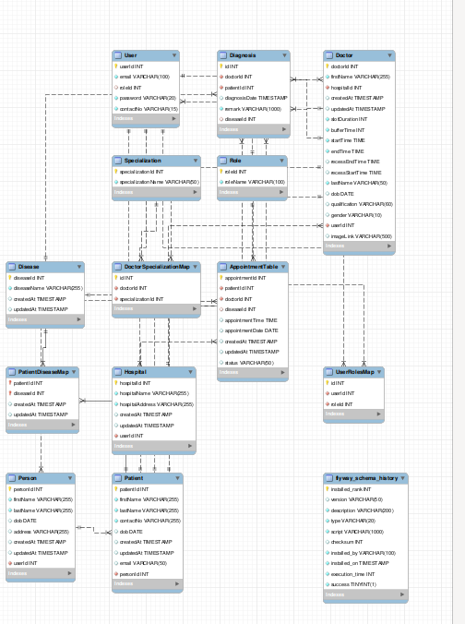

[Figure 5.3.1-ER Diagram]

**5.4 RestApi Resources**

Rest apis for the CRUD operations and business logic implementation will be implemented.

* **User :** For the Creation of the user, updating details and getting user details
* **Auth :** For the authentication and authorization features implemtation to avoid security flaws
* **Patients :** Adding and managing the patient list by the user
* **Hospital :** For registering and managing adminside activities for the hospital administration
* **Doctor :** For managing the doctors data and also managing and keeping track of their appointments
* **Appointment :** For managing and keeping track of the appointment resources and availability of the slots.

**Chapter-6: Implementation**

**6.1 Tools**

For the implementation of the project I used the following tools

* VS Code which is a quite popular code editor that can have many developer friendly extensions to make coding maintainable.
* PostMan works as a client and is really helpful for rest api testing where request can be saved and environment can be set up.
* Angular CLI is a powerful tool that makes the Angular development easy and does a lot work on user’s behalf

**6.2 Module Specification and Overview of Implementation**

* **Module Specification**

In this web application of appointment system there are primarily 3 modules Hospital, Doctor and User.

* Hospital Module is meant to be accessed by the Hospital Administrators who can keep the checks of the system
* Doctor Module is meant to be accessed by the Doctors who can have their associated information and controls
* User Module is meant to be used by the people who can leverage the system and can book appointments.
* **Overview of Implemntations**
* **Landing Page**

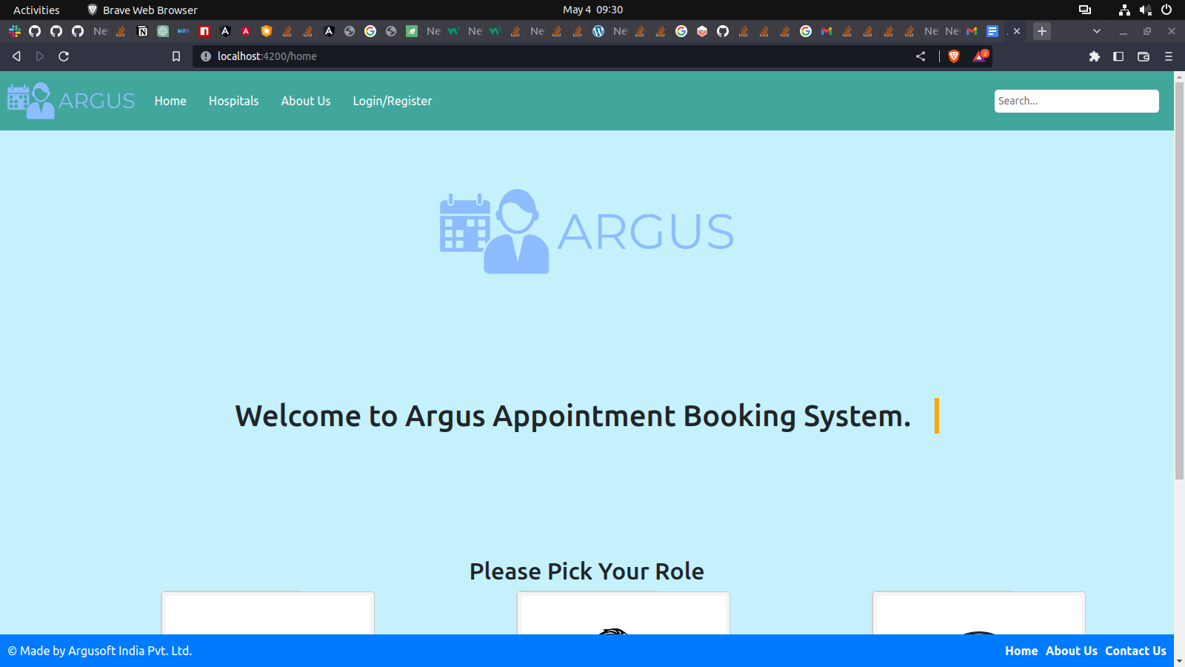Landing page will be the first page that will be displayed to the person using the system, from here onwards they can pick their role and continue accordingly

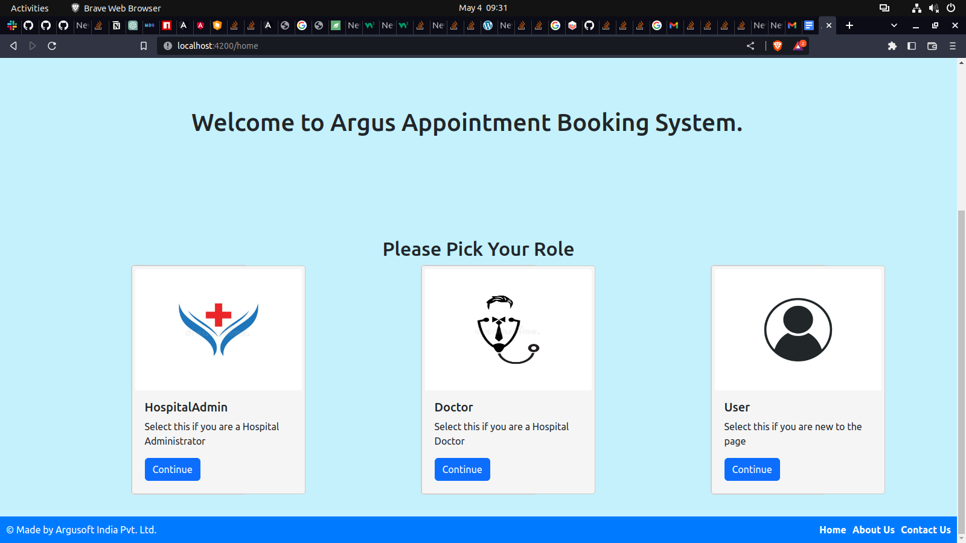[Figure 6.2.1-Landing Screen Page Welcome Message]

[Figure 6.2.2-Landing Screen Page Role Selection]

* **­­­Doctor List**

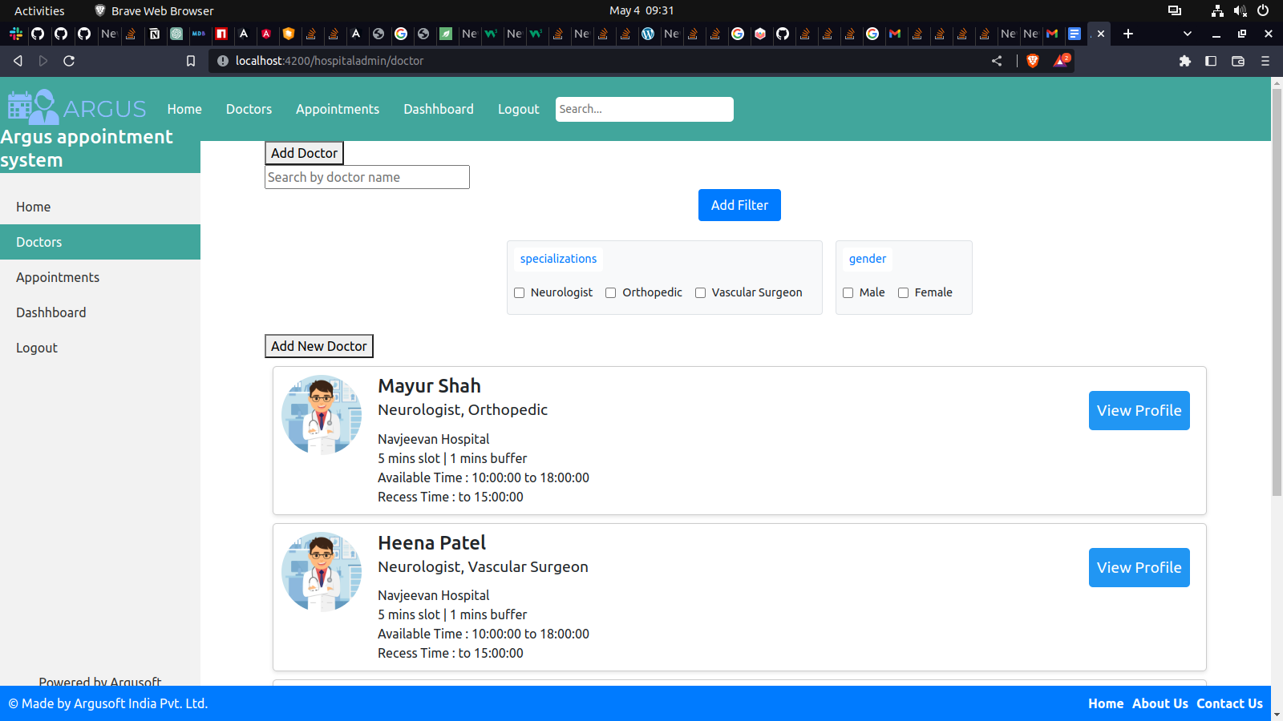Through this screen admin or user can view list of doctors and can search or filter them. And Admin can also add , update or remove the doctor.

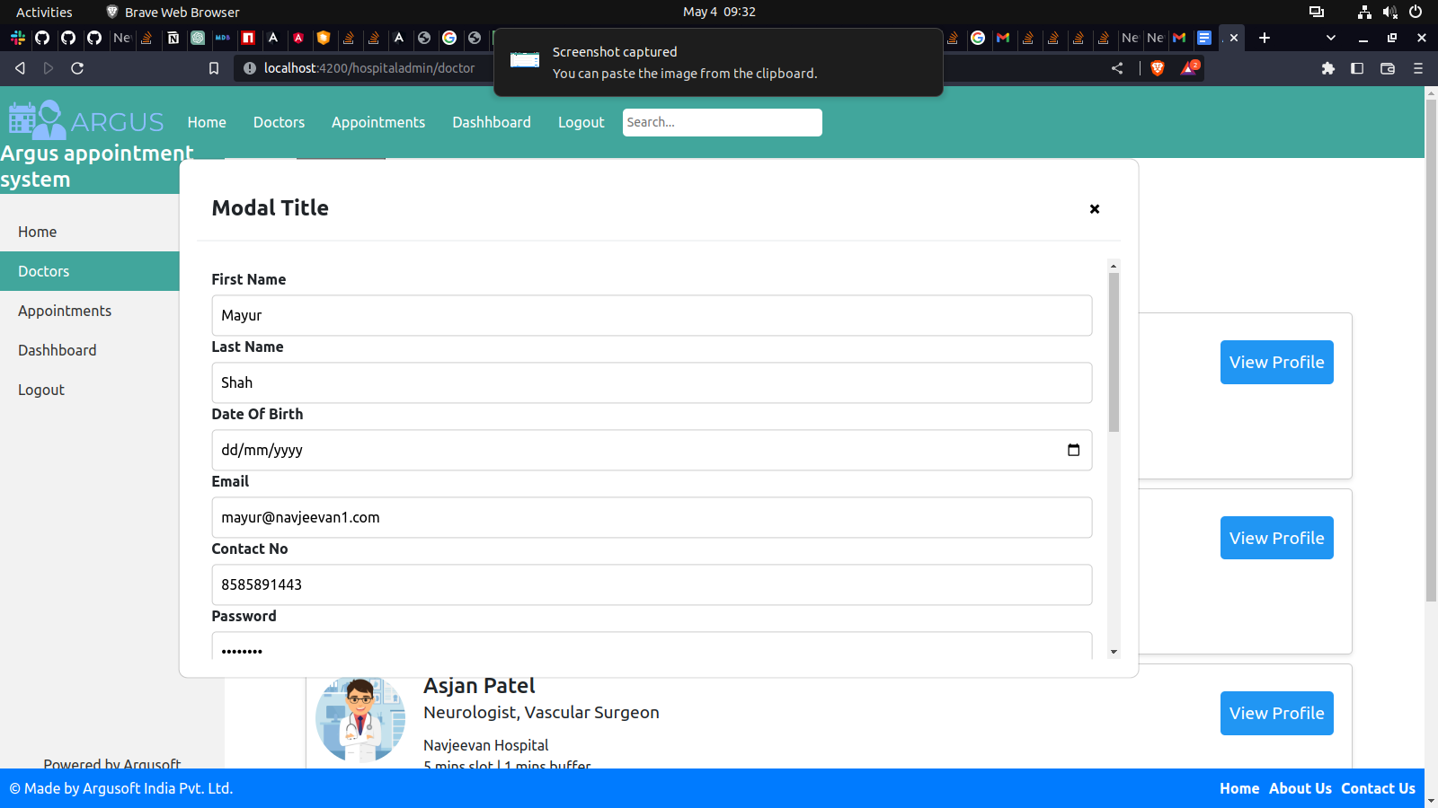[Figure 6.2.3-Doctor List]

[Figure 6.2.4-Manage Doctors]

* **Appointments**

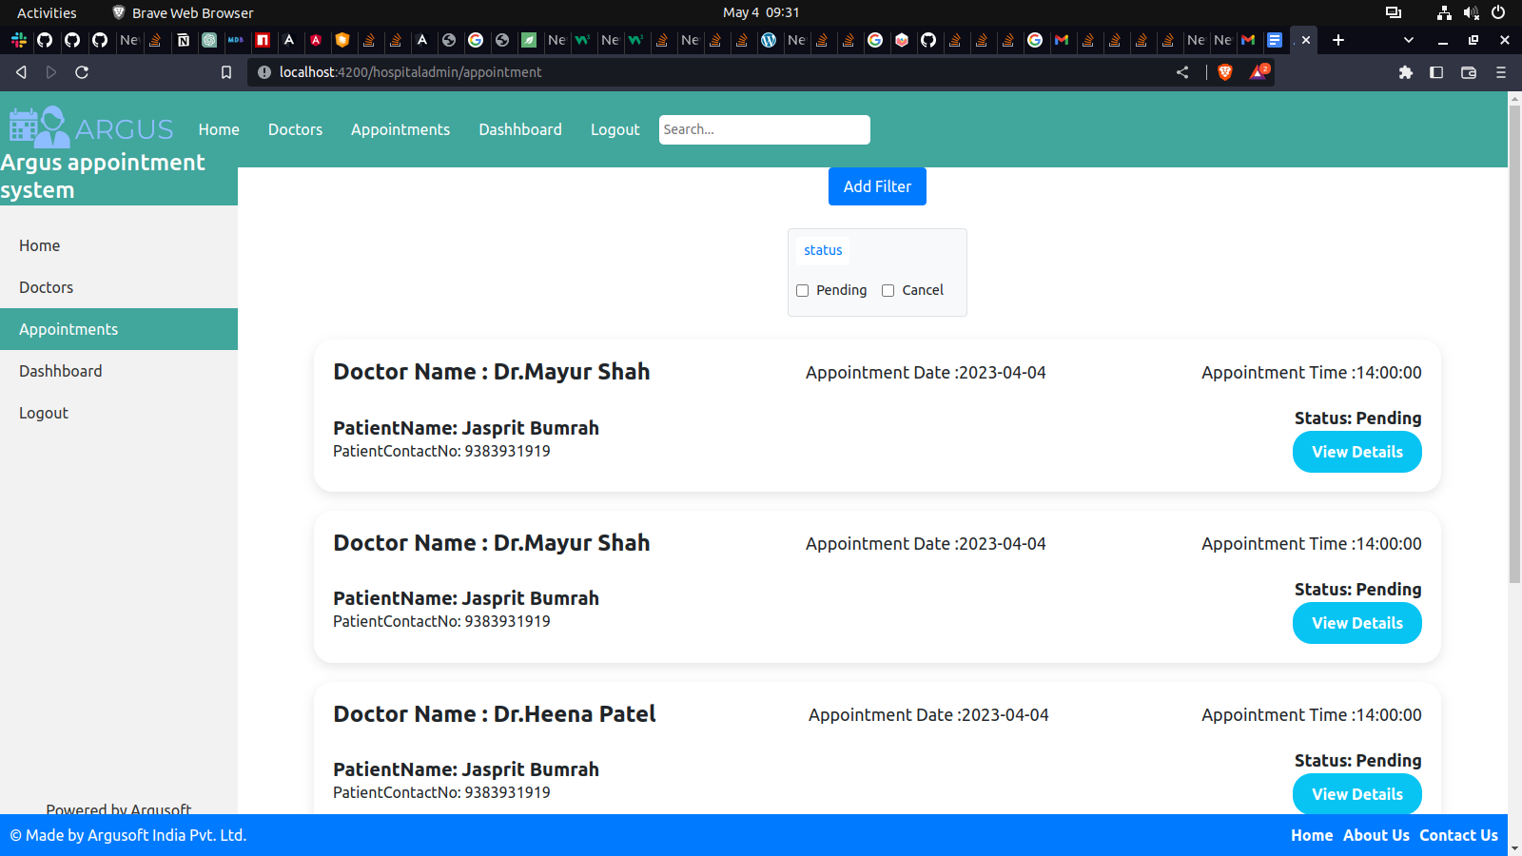Through this screen doctors, hospitals and User can keep track of all upcoming and past appointments

[Figure 6.2.5-Appointment Page]

* **Patients**

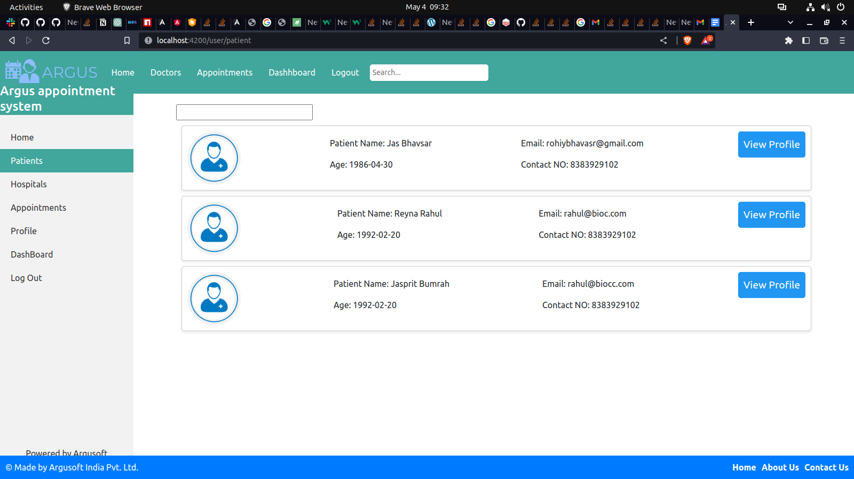Through this screen user can view patients all track and past details and can also modify details.

[Figure 6.2.6-Patient Page]

* **Dashboard**

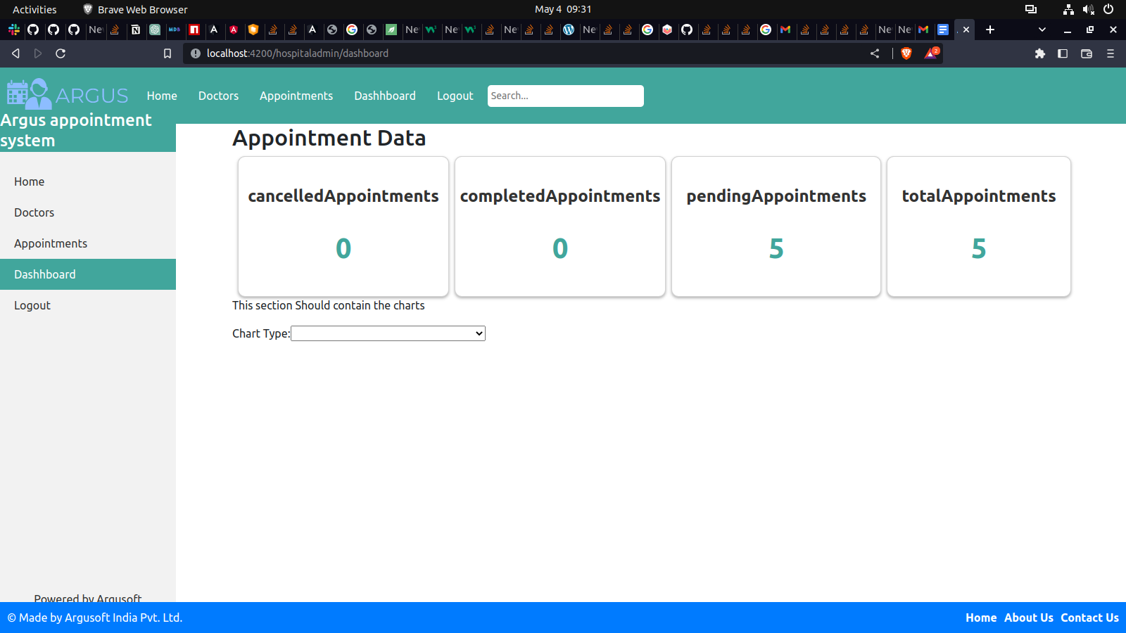Dashboard is useful for users to view statstics and also visualize theire data to gain better insights

[Figure 6.2.7-Dashboard Page]

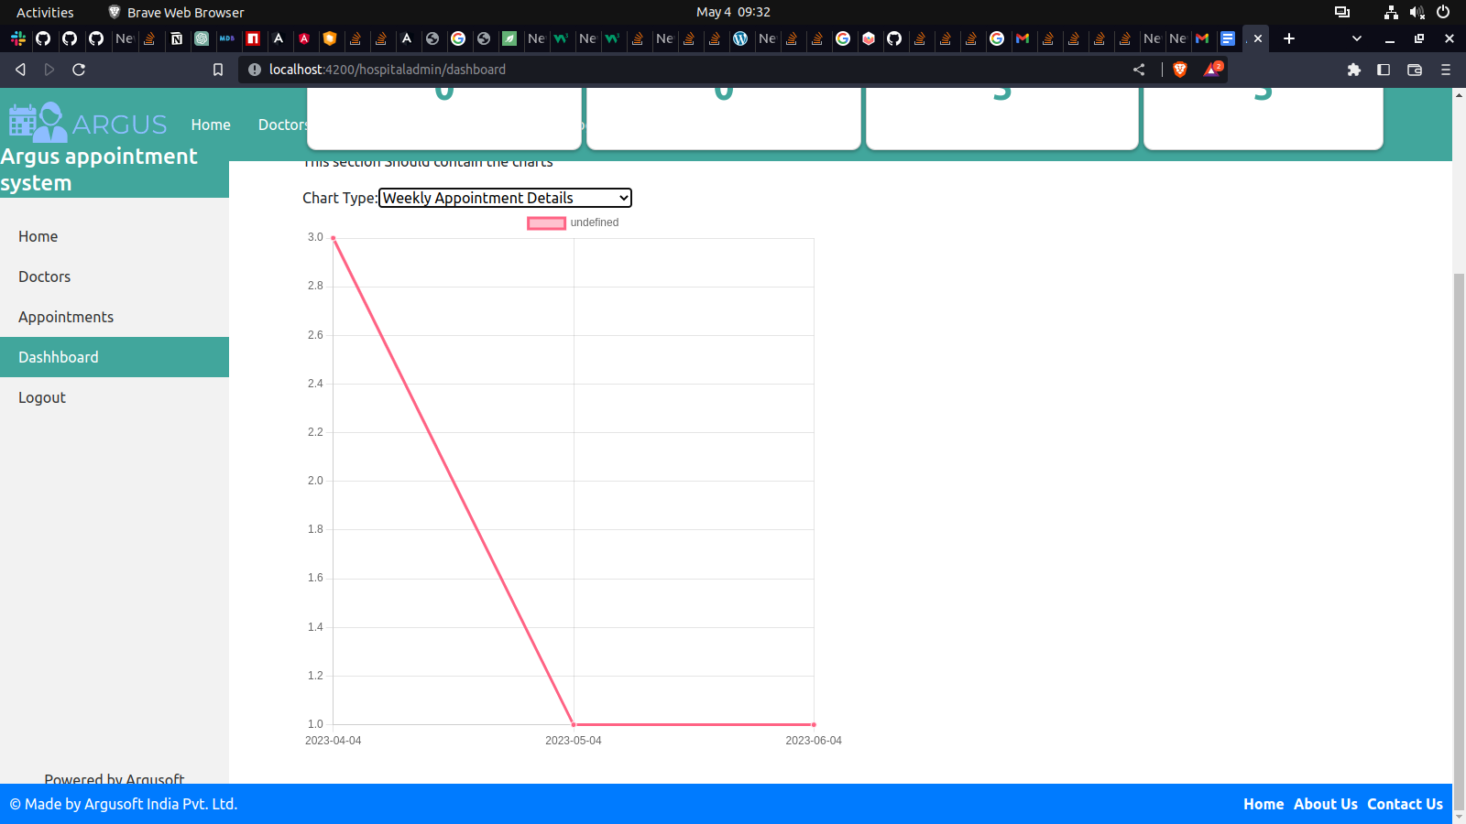

[Figure 6.2.8-Dashboard Page Chart]

**Chapter-7: Testing**

**7.1 Introduction and requirement**

Testing is the essential part of the software development process. The software that is developed can face many cases that can make it out of service to avoid certain condition in delivered project. Testing is essential step to avoid future damage and improvise the quality of the system.

**7.2 Test cases from development point of view**

During development of the java application in the backend junit tests are written and for frontend testing is being performed via karma utility in angular

* Insertion of the data from apis
* Read the correct data via apis
* Update the targeted resource via apis
* Delete the requested resource apis
* Role based authorization
* Display of proper error related codes on unusual flow of exection
* Validations at the user interface and backend
* Make application usable in slow connections via lazy loading and avoiding overhead.

**7.3 Test cases from system usecase point of view**

* User can add multiple patients and can book appointment for all of them
* Hospital admin can add remove and update the doctors
* Doctor can login to the system and view appointments associated with her/him
* Hospital admin can gain insights via correctly updated charts
* User can cancel the appointment
* User can keep the track of appointment

**Chapter-8: Conclusion and Discussion**

**8.1 Overall analysis of Internship**

Spending time in institute other than academic was a quite exciting experience for me. I learnt many things which I have mentioned earlier in the report from technologies to team work. I would summarize it as a great experience. Learning to tackle the issues and the good introduction to the IT vocabularies. I can leverage this experience in my professional journey ahead.

**8.2 Dates of Continuous evolution**

* **C.E. – I : 18th March 2023**
* **C.E. – II : 29th April 2023**

**8.3 Problems encountered and solutions**

During internship I struggled developing and designing frontend. I found it hard to do code in front end technologies. I discussed this issue and the best solution is to learn it more via doing more practice and coding. I used them in my projects and understood the topics which I earlier found really hard.

**8.4 Future Enhancement**

This internship made me a quick learner this quality can be helpful to me in my career paths ahead. I can also make this experience useful for development of the system that can be useful.